**Test Approach and Bug Report**

**Test Approach**

The ‘Buggy Cars Rating application’ has been tested using the Chrome browser and Android OS. The test design techniques such as ‘Boundary Value Analysis (BVA) and ‘Equivalent Partitioning’ was used for fields like ‘Age’ which is on the ‘Profile’ page, since it allows only values from 0 to 95. A system testing was performed by both manual and automation testing. The ‘Page Object Model’ has been used to develop the automation scripts. And also, some security testing scenarios such as passing URLs directly, were executed to validate that unauthorized users are not allowed to vote. Some defects have been detected during the test execution and most critical bugs out of them are reported below.

**Bug Report**

1. **Heading:** The ‘Home Page’ is not displayed, when the user logged out.

**Severity:** High

**Priority:** High

**Description**: The system does not get navigated to the ‘Home Page’ but remains on the existing page, even though the user logged out.

**Note:**

Once the page gets refreshed, then the system gets navigated to the ‘Home Page’.

**Steps to reproduce**:

1. Log in to the ‘Buggy Car Rating’ application.
2. Navigate to the ‘Profile’.
3. Click on the ‘Logout’ link.

**Actual Result**: The system remains on the existing page, even though the user logged out.

**Expected Result**: The system should be navigated to the ‘Home Page’, when the user clicks on the ‘Logout’ link.

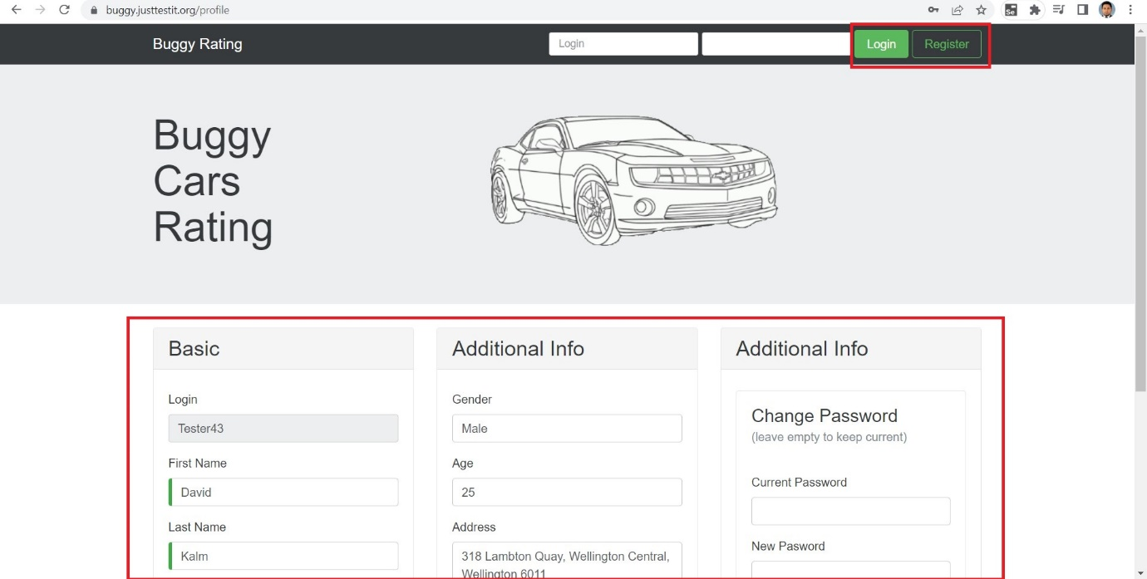

2. **Heading**: An issue with sorting on the ‘Ranking’ columns.

**Severity:** High

**Priority:** High

**Description**: Values of the ‘Ranking’ columns of the tables that are in the ‘Popular Make’ and ‘Overall Rating’ pages, are not sorted in either ascending or descending orders.

**Steps to reproduce**:

1. Launch the Buggy Cars Rating website.
2. Navigate to the ‘Popular Make/Overall Rating’ pages.
3. Sort the table from ‘Votes’.
4. Click on the ‘Rank’ column heading to sort the values from the rank.

**Actual Result**: Values of the table are not sorted from rank.

**Expected Result**: Values of the table should be sorted from rank.

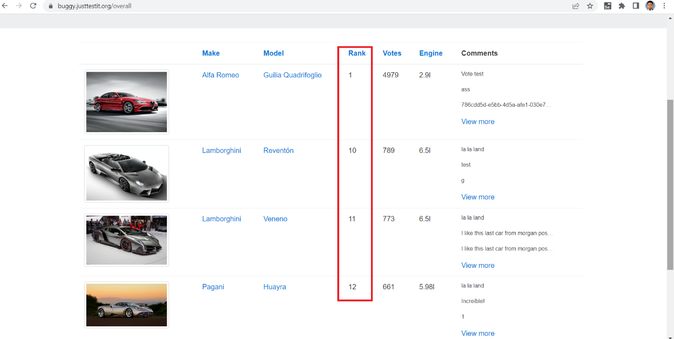

3. **Heading:** Blank pages can be loaded through the pagination link.

**Severity:** High

**Priority:** High

**Description**: Blank pages are displayed when the user keeps pressing the pagination link. (Towards the incremental end)

**Steps to reproduce**:

1. Log in to the ‘Buggy Car Rating’ application.
2. Navigate to the ‘Overall Rating’ page.
3. Keep pressing the pagination link to load more pages.

**Actual Result**: Blank pages are displayedwhen the user clicks on the pagination link, even after it’s loaded the last available page.

**Expected Result**: The pagination link should be disabled when it’s reached the last page.

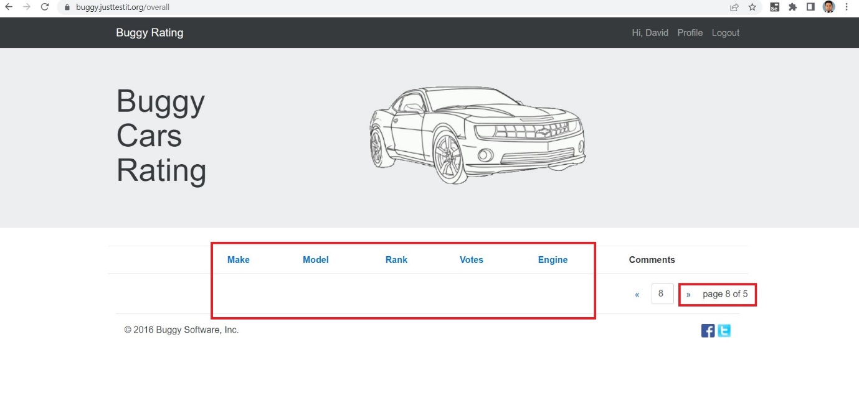

4. **Heading**: The ‘Buggy Rating’ link is not working.

**Severity:** Medium

**Priority:** Medium

**Description**: The system is not navigated to the ‘Home Page’ when the user clicks on the ‘Buggy Rating’ link from the ‘Popular Make’ page.

**Steps to reproduce**:

1. Log in to the ‘Buggy Car Rating’ application.
2. Navigate to the ‘Popular Make’ page.
3. Click on the ‘Buggy Rating’ link.

**Actual Result**: The ‘Buggy Rating’ link is not working and the system remains on the ‘Popular Make’ page.

**Expected Result**: The system should be navigated to the ‘Home Page’.

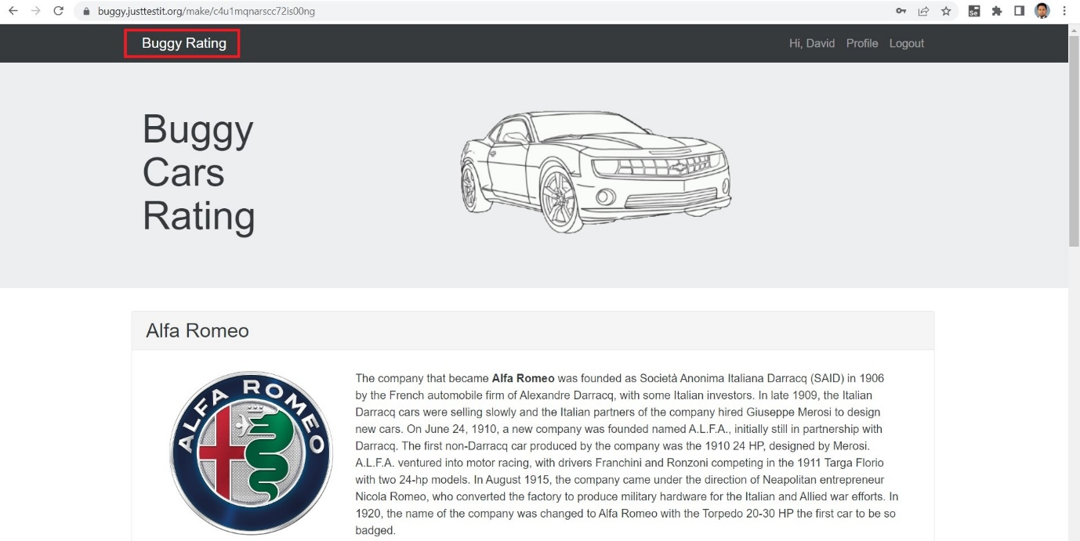

5.**Heading**: Spelling mistakes can be observed on the ‘Profile’ page.

**Severity:** Low

**Priority:** High

**Description**: Spelling mistakes can be observed on the ‘New Password’ label and the ‘Success Message’ of the profile update process.

**Steps to reproduce**:

1. Log in to the ‘Buggy Car Rating’ application.
2. Navigate to the ‘Profile’ page.
3. Validate the ‘New Password’ label.
4. Update the ‘Profile’ and click on the ‘Save’ button.
5. Validate the ‘Success Message’.

**Actual Result**: The ‘New Password’ label and the Success Message’ are displayed as ‘New Pasword’ and ‘The profile has been saved successful’

**Expected Result**: The ‘New Password’ label and Success Message’ should be displayed correctly (‘New Password’ and ‘The profile has been saved successfully’)

